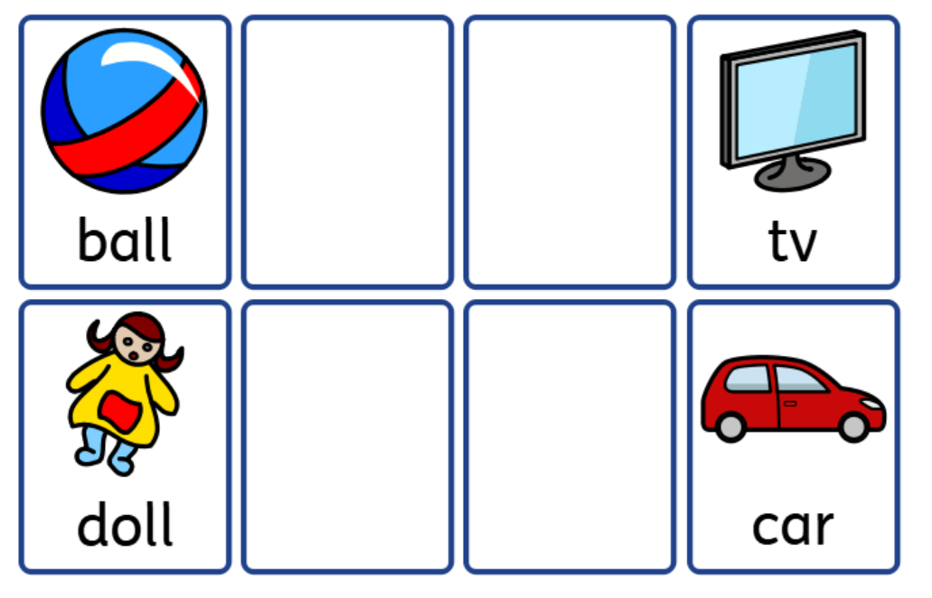
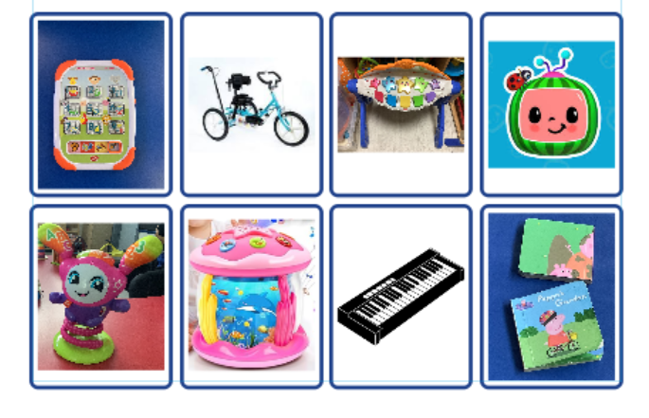
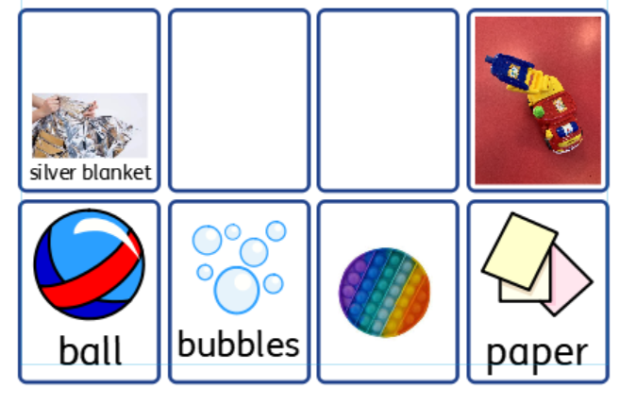
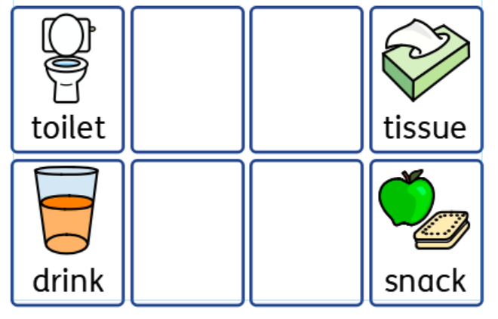
Try to offer a range of choices that motivate individuals, and meet their needs e.g. personal needs, play activities, meals, snacks, etc.

Choice boards can contain 2 or more choices. Try not to overwhelm the user, but motivate with what they may choose/not choose?

Choice boards may contain a combination of photos and symbols.

